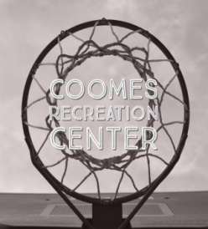
Coomes Recreation Center Gymnasium Rules & Regulations
- Shoes and shirts must be worn at all times.
- Appropriate footwear is required (i.e. athletic shoes only, no shoes that will scuff or damage the floor or flip-flops).
- No food, glass containers, or tobacco products.
- Children under the age of 12 must be accompanied by an adult.
- No Kicking or Throwing Basketballs.
- The use of profanity or inappropriate language is prohibited.
- Treat the facility with respect, remove your water bottles and trash when leaving the area.
- Horseplay, screaming, and fighting will not be tolerated.
- Please report faulty or damaged equipment to a staff member immediately.
- Be watchful of your belongings, we are not responsible for lost or stolen items.
- Be respectful to all staff and other patrons.
- Patrons and guests are required to check in at the front desk, entrance through the side or back doors is not permitted.
- Headphones must be worn to listen to personal music (i.e. no speakers will be allowed.).
- Staff members reserve the right to remove any member or guest from the area if they exhibit behaviors that are believed to be unsafe or inappropriate.
- Half of the gym is reserved for organized basketball; however if the gym is busy the staff on duty reserve the right designate the whole gym as open play.
- Scheduled programming takes precedence in regards to gym use.
- The gym may be closed up to an hour before scheduled programming. Please check the daily and monthly schedules for a list of scheduled events.
- Failure to adhere to these rules and instruction from staff will result in staff interaction; further failure of adherence may result in removal from the property and suspension.
- Dunking/hanging on the rim is not permitted in the gymnasium. If a player dunks/hangs on the rim and there is damage to the rim or backboard the player may be liable for the cost of replacement up to $1,000.

